Kinematic Assignment

# Index

1. Introduction
2. Analyzed mechanisms
   1. Push-up type
   2. Pod-pull type
   3. Pod-rocker type
3. Comparison between previous mechanisms
4. Conclusion

**For each mechanism**:

* Degree of freedom analysis, number of bodies and types of joints
* Description of the approach used to describe the chain mechanism (Recursive, Global o Natural coordinates) and the graph to describe the mechanism
* Initial configuration problem and assembling mode
* Position analysis
* Velocity analysis
* Velocity ratios and singular configurations
* Optimization with inverse kinematic problem (based on the random data that we have fixed)
* Comments about the following performance index of the mechanism:
  + Velocity ratio between s(t) and the angle of the flap
  + Piston stroke

# Nats (Push-up type)

The pull-pod type system is, from the kinematic point of view, a close chain mechanism. As it is possible to see in the picture, this machine is composed by:

1. the base of the cylinder, fixed to the chassy;
2. the body attached to the piston of the actuator;
3. the rod that connect the actuator part with the movable part of the wing;
4. the flap, which has to pivot around a pin, fixed to the rear wing’s structure.

In order to analyze the mechanism, the body 1 is considered to be the ground, since that the main goal of the project is the design of the DRS mechanism.

These four bodies are connected with some joints:

* a prismatic joint, in the point B, that connects the ground and the body 2, it’s one of the possible ways to model a linear actuator;
* a revolute joint, in the point C, between the bodies 2 and 3;
* a revolute joint, in the point D, that links the DRS mechanism with the movable flap;
* a revolute joint, in the point E, that connects the movable flap with the structure of the rear wing, considered to be the ground.

Using the Grübler for the 2D mechanisms, it is possible to calculate the degrees of freedom of the pull-pod system:

dof = 3* (nb - 1) - 2*(nc_2) - 1(nc_1), that in this case has the following result

dof = 3* (4 - 1) - 2*4 = 1

This analysis is correct because the mechanism can be described by a single coordinate, chosen as independent.

# Mattia (Pod-pull type)

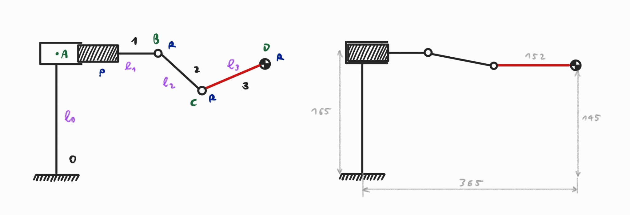

The pod - pull mechanism is composed of four bodies (one of them considered as ground), connected to each other with three revolute joints (B, C, D according to the image above) and a prismatic joint (A). Using the Grubler’s rule, it is possible to calculate the number of degrees of freedom: 3* (4 - 1) - 2*4 = 1.

We have derived the 2D kinematic model using the recursive approach: in particular the kinematic chain was broken on the revolute joint B. In order to close the loop, we have imposed equal to zero the distance between the two points in B, so that they might be joined together. The following analysis was carried out using the software Maple.

**Position analysis**

In order to solve the position problem, we have chosen the lengths deriving them from a 3D model of the wing: L0 = 144, L3 = 152, L4 = 365, L5 = 145. The other data was derived imposing the constraints so that the mechanism could be closed (L1=70, L2=143.0035, S0 = 50). Afterwards we have defined theta2(t), theta3(t) as dependent variables, and s(t) as independent variable. Imposing as initial condition s(t) = 0, we have derived the values of the dependent variables so that the constraints were respected. Finally we have drawn the mechanism in two different configurations, when the wing is closed and when it is opened, following the DRS activation. These image are shown below:

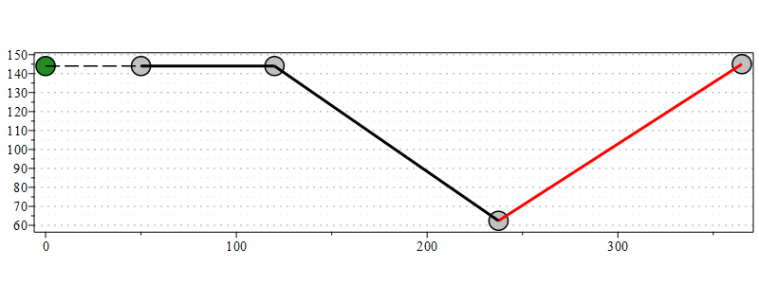

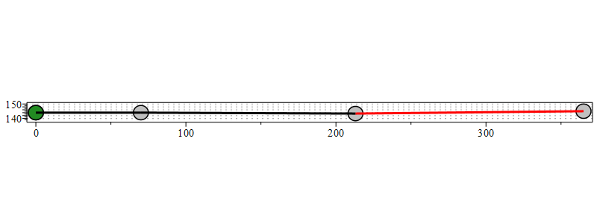

# Albi (Pod-rocker type)

## Kinematic analysis: global approach

This mechanism has a higher number of free bodies than the previous ones (3 instead of 2 considering the rod joint as a pure constraint) and two loops. Because of this it has been modeled using a global approach, making it easier to define the constraints, especially the rod joint.

The three bodies are:

1. **Piston**, defined by its length;
2. **Rocker**, modeled as a triangle with a given length for all three sides. With these data it’s possible to compute the barycenter (set as COM) and define auxiliary frames for each vertex;
3. **Wing**, defined by its length;

each one having three degrees of freedom (2D problem).

The constraints are:

* **Prismatic joint** between ground and piston.
* **Revolute joint** between rocker and ground.
* **Rod joint** between rocker and piston with length Lrod.
* **Revolute joint** between wing and ground.
* **Cam joint** between wing and rocker. Being the wing modeled as a rod, the cam joint axis is along the wing itself.

**mechanism image**

Using the Grübler for the 2D mechanisms, it is possible to calculate the degrees of freedom of the system:

dof = 3* (nb-1) - 2*(nc_2) - 1(nc_1), that in this case has the following result

dof = 3* (4 - 1) - 2*3 - 1*2 = 1

This analysis is correct because the mechanism can be described by a single coordinate, chosen as independent.

To evaluate feasible parameter values in order to study this mechanism (it is too complex to be evaluated without assigning these values) first a simulation on maplesim has been carried out.

The used parameter values are:

* LP = 10 cm
* LT1 = 8 cm
* LT2 = 10 cm
* LT3 = 6 cm
* LW = 15.2 cm (by cad)
* Lrod = 7 cm
* XT = 18 cm
* XW = 36.5 cm (by cad)
* YP = 14.5 cm
* YT = 7 cm
* YW = 14.5 cm (by cad)

## Position analysis

### Analytical solution

From the analytical position analysis it results that the mechanism has two different assemblies.   
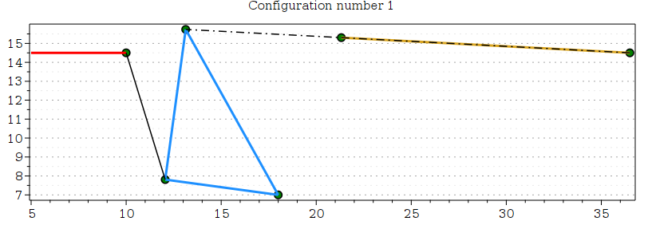

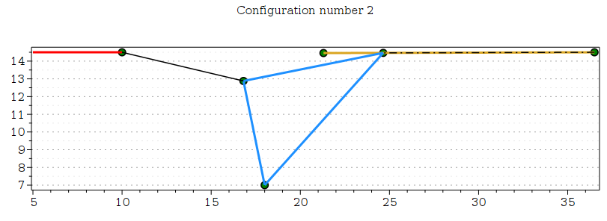Looking at the plot of the wing angle as a function of the piston position, the two configurations widely differ from each other.

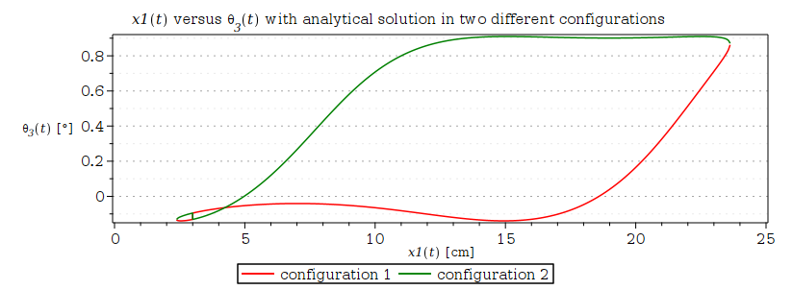

For this application, remembering that from the cad it results that the wing moves between 0 and 0.61 [rad], configuration two better fit the application:

* It reaches the desired range for lower piston displacement.
* Also by observing the mechanism plot, the assembly is more mechanically feasible.

### Numerical solution

From the numerical position analysis it appears that the mechanism admits two more configurations.

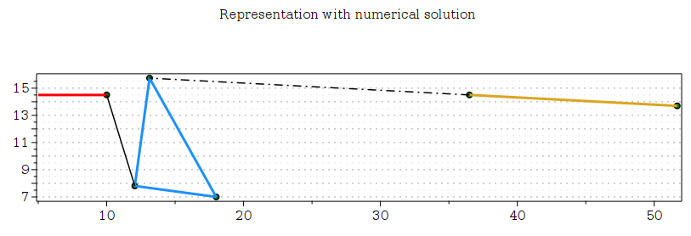

This is probably due to the fact that the tan(x) function is periodic (the analytical solution is constrained between $±π/2$) and the numerical method found a solution with θ3 greater than the analytical solution for config. 1 by π[rad].

So we can conclude that four possible assemblies exist. The one preferred is the wing on the left side with the rocker being closer to it.